**Work – How to use Analog and Digital Signal Communication Engineering Software usage**

**Program 1: Amplitude Modulation**

Step 1: Run the program in command line

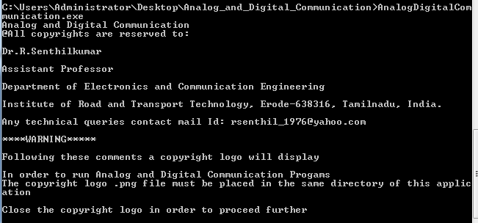

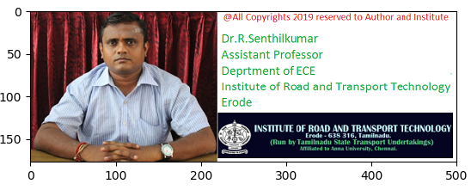

**Step2:**

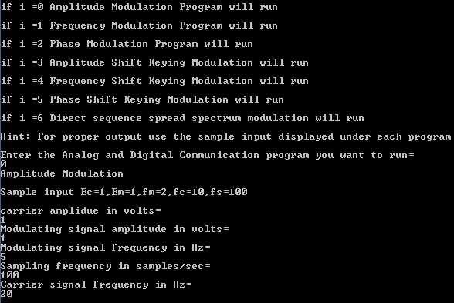

**Result:**

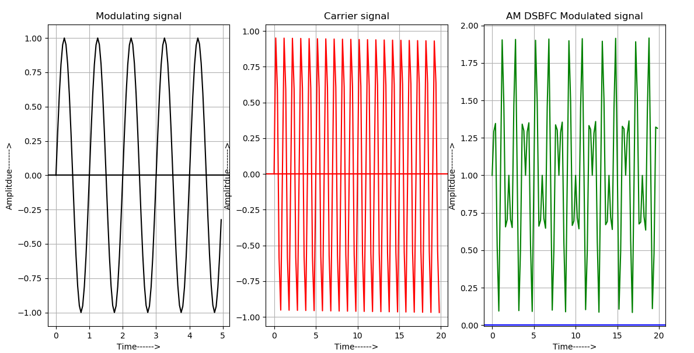

**Program 2: Frequency Modulation**

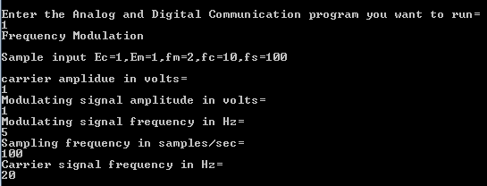

**Result:**

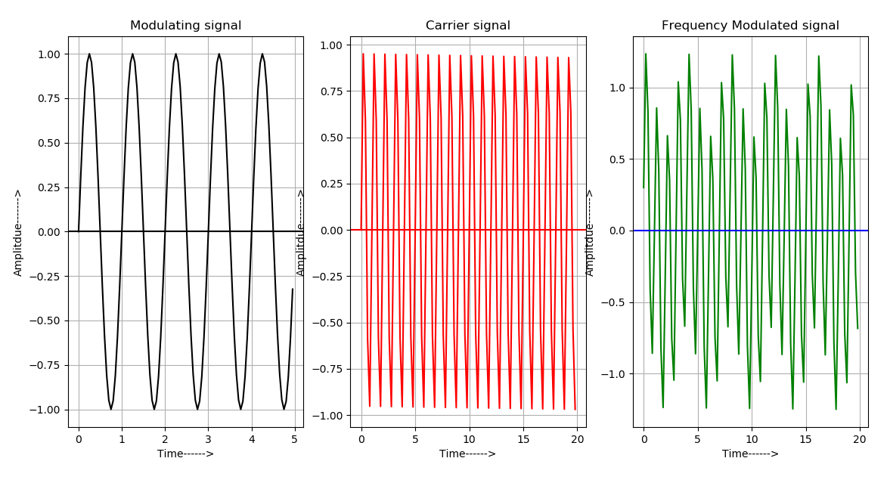

**Program 3: Phase Modulation**

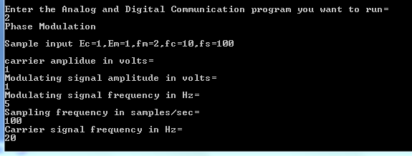

**Result**

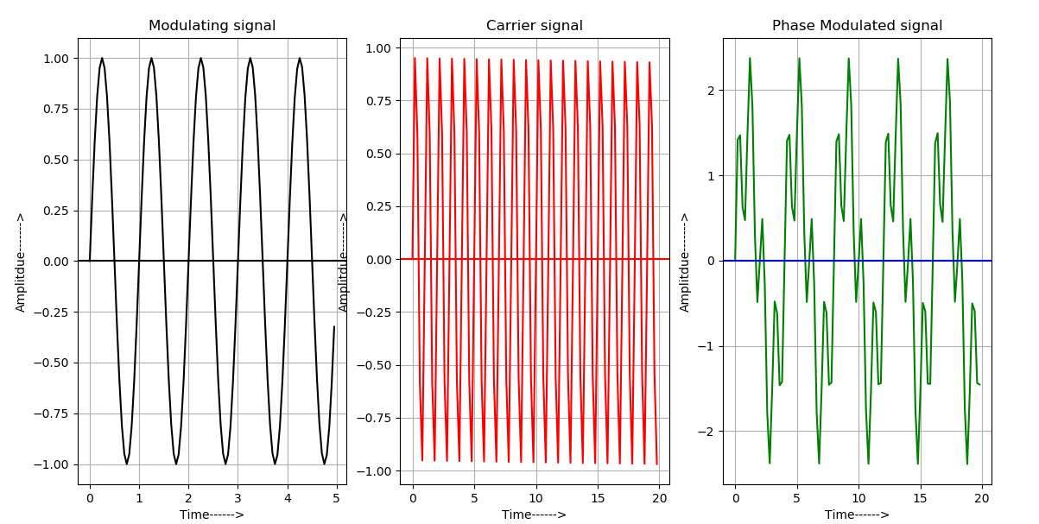

**Program 4: Amplitude Shift Key Modulation**

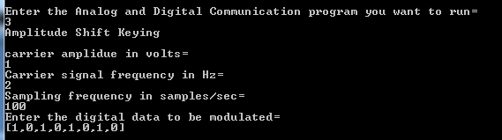

**Result**

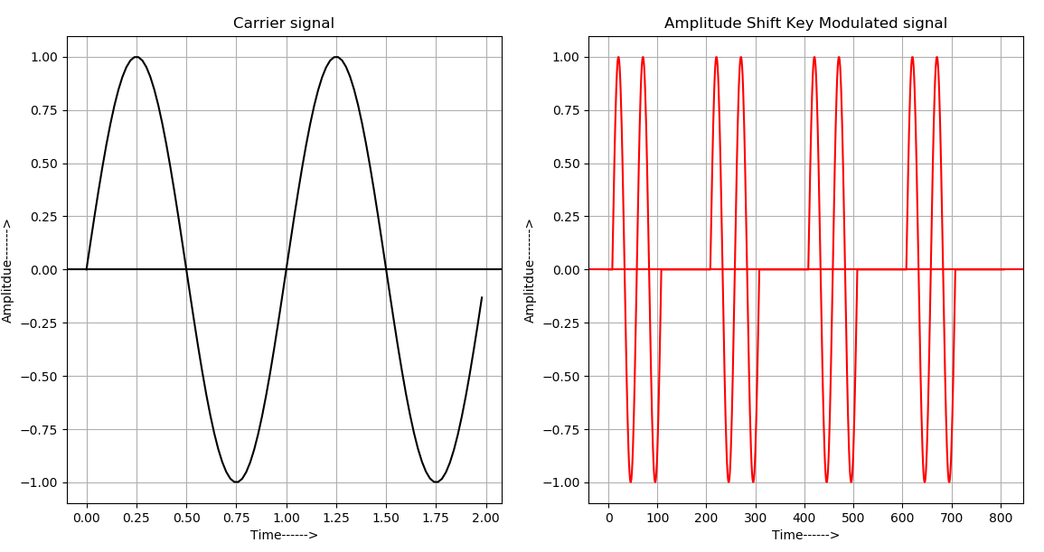

**Program 5: Frequency Shift Key Modulation**

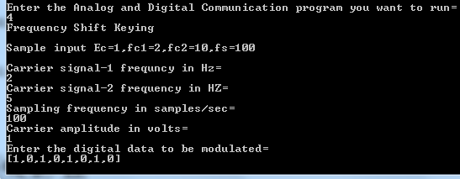

**Result**

**6**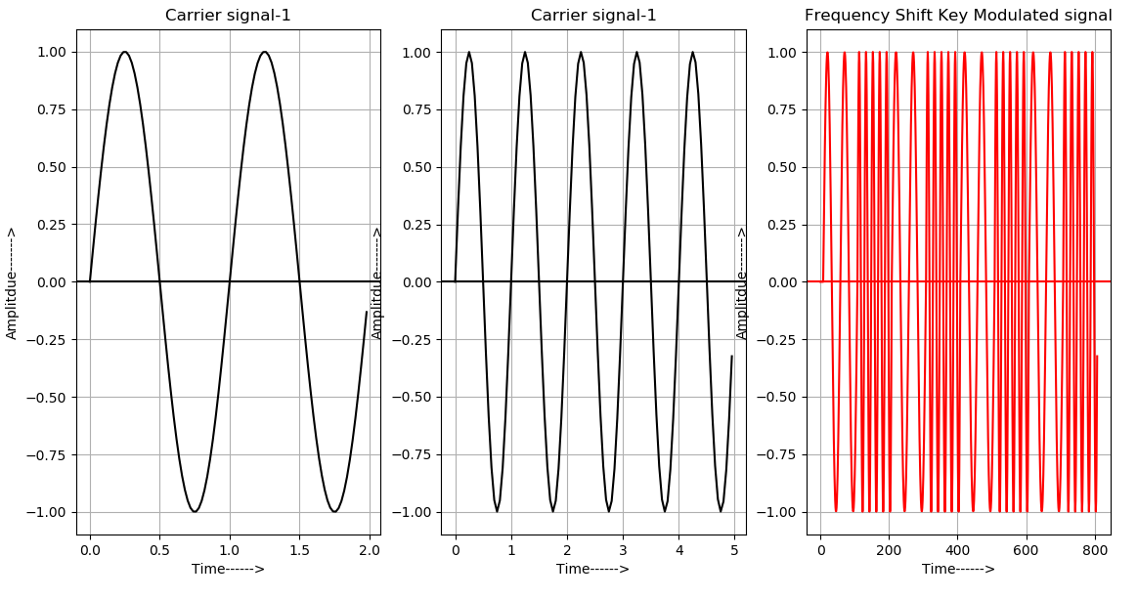

**Program 6: Phase Shift Key Modulation**

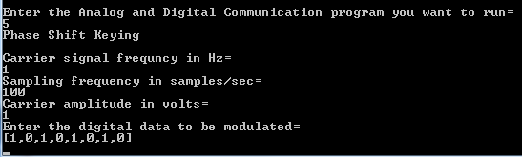

**Result**

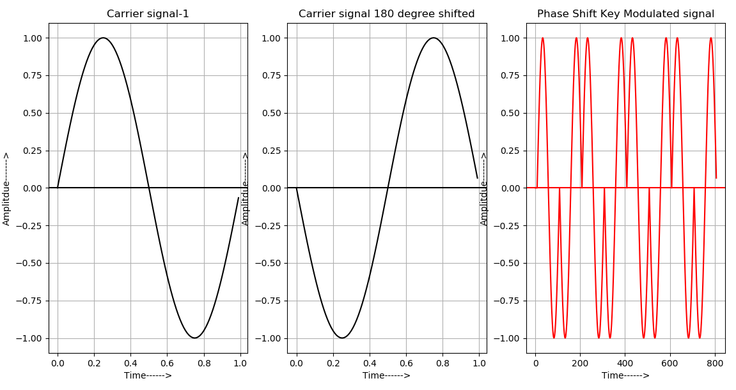

**Program 7: Spread Spectrum Modulation Technique**



**Result**

